# Supplementary Materials: Perturbation-driven echo-like superfluorescence in perovskite superlattices

**Qiangqiang Wanga,+, Jiqing Tana,+, Qi Jiea, Hongxing Dongb,*, Yongsheng Hua, Chun Zhoub, Saifeng Zhangc, Yichi Zhongb, Shuang Lianga,d, Long Zhangb,e, Wei Xiea,* and Hongxing Xua,d,\***

aState Key Laboratory of Precision Spectroscopy, School of Physics and Electronic Science, East China Normal University, Shanghai, 200241, China

bKey Laboratory of Materials for High-Power Laser, Shanghai Institute of Optics and Fine Mechanics, Chinese Academy of Sciences, Shanghai 201800, China.

cDepartment of Physics, Shanghai University, Shanghai 200444, China.

dCenter for Nanoscience and Nanotechnology, and School of Physics and Technology, Wuhan University, Wuhan 430072, China.

eHangzhou Institute for Advanced Study, UCAS, 310024 Hangzhou, China.

+These authors contributed equally.

* Wei Xie, [wxie@phy.ecnu.edu.cn](mailto:wxie@phy.ecnu.edu.cn); Hongxing Dong, [hongxingd@siom.ac.cn](mailto:hongxingd@siom.ac.cn); Hongxing Xu, hxxu@whu.edu.cn.

## Part Ⅰ: Supplementary Figures.

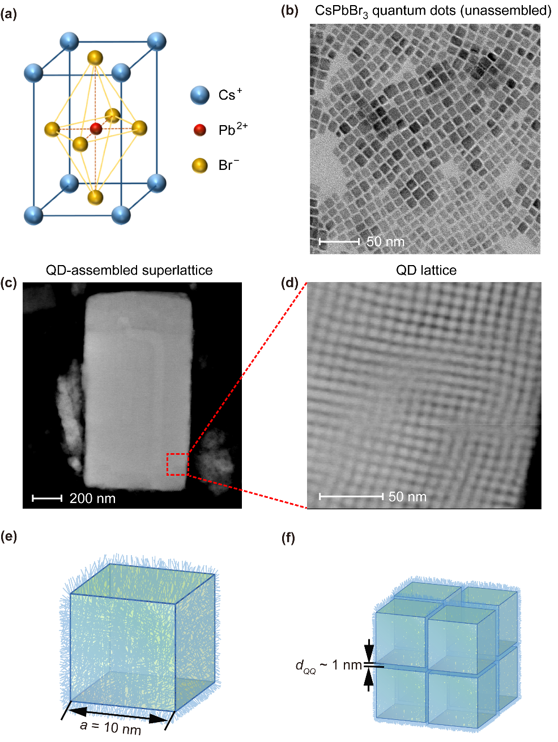

**Fig.** **S1 Perovskite superlattice sample.** (a) Crystal structure of CsPbBr3. (b) High resolution transmission electron microscopy image of the unassembled CsPbBr3 quantum dots (QDs). (c) QD-assembled superlattice. (d) Close-up view of the red dotted box in c. A regular lattice of QDs is displayed, indicating the high quality of the superlattice sample. (e) Single quantum dot and its surrounding oleylamine and oleic acid ligands (whiskers), the size of a QD is about 10 nm. (f) The adjacent quantum dots in the superlattice have a certain spatial distance () due to the ligands.

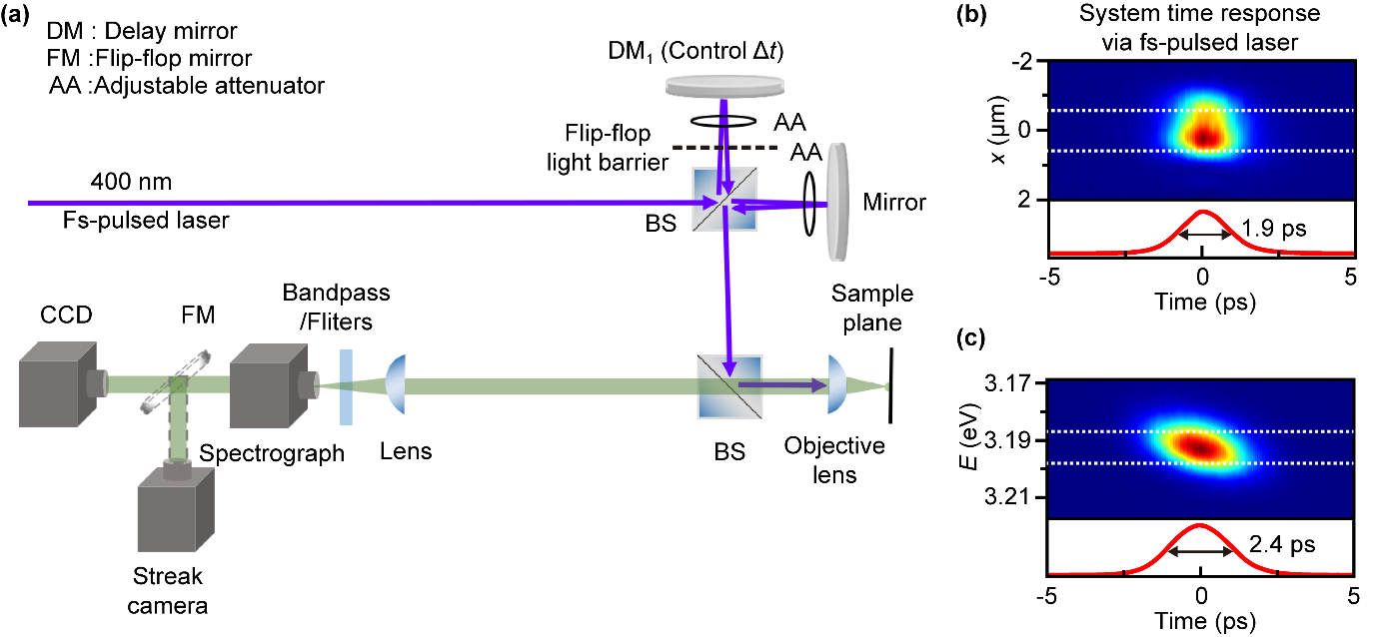**Fig.** **S2 Experimental setup and time resolution of the detection system.** (a) Experimental configuration. The delay mirror DM1 controls the time intervalbetween the first and second excitation pulses. The double-pulse excitation configuration can be switch to the single-pulse excitation by blocking the light path of DM1. Photoluminescence signals are collected by an objective lens and spectrometer. A streak camera is used to measure the dynamics of the PL radiation. (b), (c) Time responses of the detection system are obtained via the femtosecond-pulsed laser. The time resolutions of the detection system are and for the cases without and with the spectral resolution through the grating, respectively. The corresponding dynamic curves (signals obtained by integrating the white dashed area) are shown below. The flip-flop light barrier is used to switch the single-pulse/double-pulse experimental configuration.

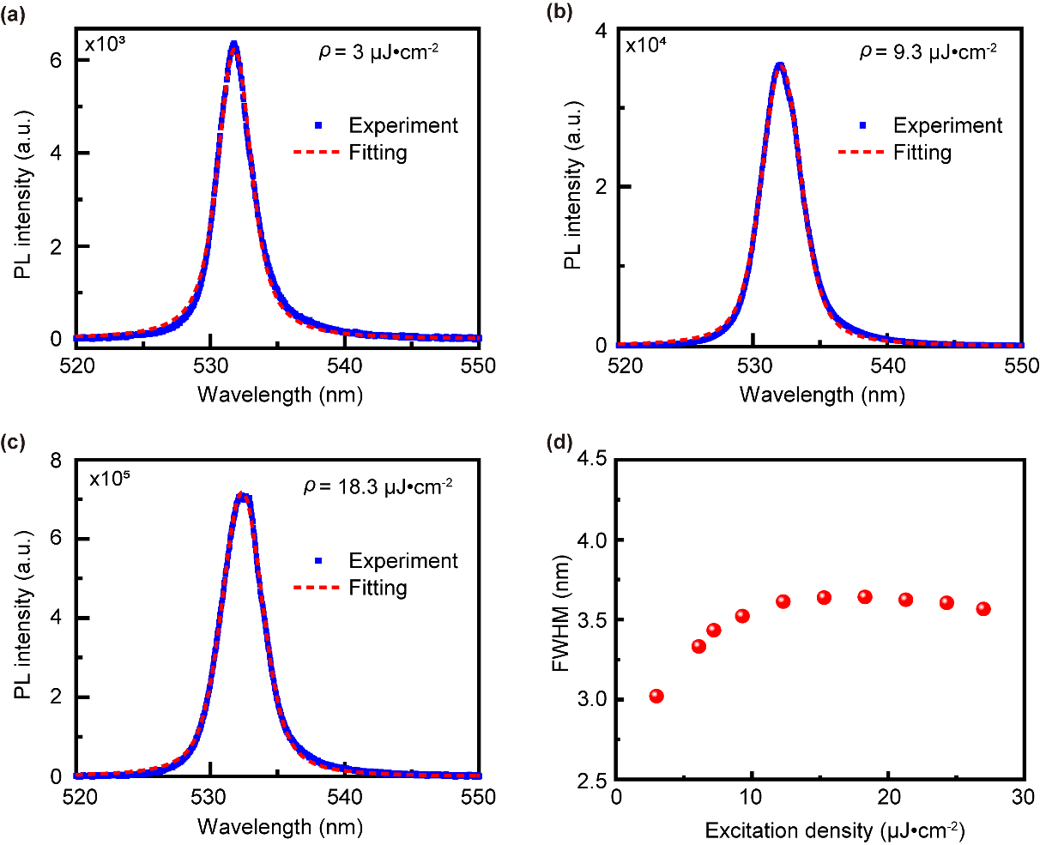

**Fig. S3 Spectral full width at half maximum (FWHM) vs the excitation density.** (a)-(c) Superfluorescence steady-state spectra at three excitation densities, blue squares are experimental data, red dashed lines are based on the Voigt function (convolution of Gaussian and Lorentzian functions) fit. (d) Excitation density  vs the spectral FWHM of superfluorescence. As the excitation density increases, the variation in the spectral FWHM of superfluorescence remains relatively small. Experimentally, a significant reduction in FWHM was not observed, consistent with recent research findings on superfluorescence18,35.

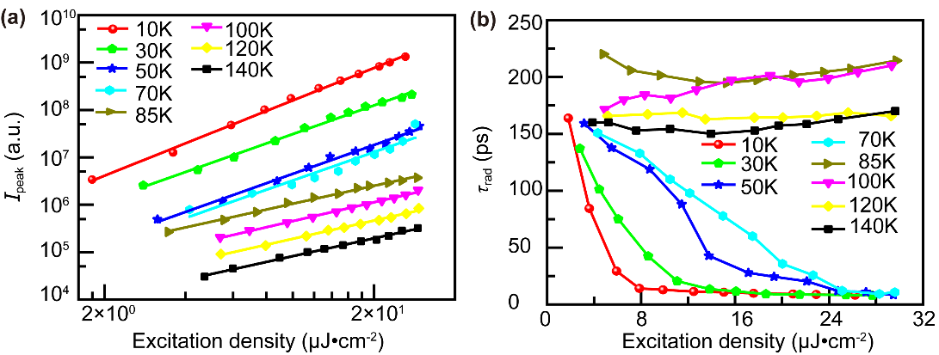

**Fig.** **S4 Controlling the cooperative radiation behavior by tuning the sample temperature.** As the increasing of the excitation density, the variation trends of the peak intensity(a) and the radiative duration time (b) under the different sample temperature (T=10 K~140 K) are plotted. The many-body radiation process gradually changes from SF behavior to SE effect during the increase of temperature. The critical temperature for the phase transition is about 85 K in this QD superlattice sample with high cavity quality.

## Part Ⅱ: Estimation of the average distance of excitons

Considering the typical excitation densityand the thickness of sample, the excitation density per unit volume is

. (S1)

The reflectivity of the sample is about 0.5. In addition, the absorption coefficient of CsPbBr3 quantum dots is about . The absorption rate of photons entering the sample is calculated to be . Based on the reference to Zhong Jin team's review in 2017, the fluorescence quantum yield of CsPbBr3 quantum dots is generally greater than 0.4, and in superlattice samples, the fluorescence quantum yield can be even higher due to the phenomenon of superfluorescence36. Therefore, in this study, considering a fluorescence quantum yield of 0.5, we estimate a quantum conversion efficiency of  between the incident pumping photons and the generation of excitons.

The photon energy of pumping laser *E*0 is about 3.1 eV. Then, one can obtain the average number of excitons per unit volume:

. (S2)

The size of a QD is. Thus, average number of excitons per quantum dot is

 (S3)

and the average distance between excitons is.

Furthermore, even when considering the extreme scenario where the fluorescence quantum yield reaches its maximum value of 100% and the quantum conversion efficiency is , the average number of excitons per quantum dot is , which is significantly less than 1. Therefore, the analysis presented in the main text remains both reasonable and valid.

As shown in the experimental results in **Fig. 2(a)**, a clear dip can be observed. At this point, the total exciton concentration after two-pulse excitation is approximately equivalent to the excitation density of , where the average exciton number is even lower, not exceeding 0.06. Even if we consider the most extreme case , the average number of excitons per quantum dot does not exceed , and the average distance between excitons is . These values have minimal impact on the analysis presented in the manuscript. Therefore, it is reasonable to assume a value of 0.2 for , and the estimated results of the average distance between excitons remain reliable.

## Part Ⅲ: Theoretical Model

In this section, we derive the dynamical equations to describe the time evolution of the system and fit the experimental results shown in the manuscript. For a common interactive system consisting of  dipoles and a single-mode optical field in an effective volume , based on the mean field approximation, and dissipative Jaynes-Cummings model, the following equations are obtained:

 (S4)

Here,  is the operator of the optical field,  is the frequency. For each dipole in superlattice sample,  is the mean transition dipole moment and its frequency is in accordance with the cavity light field.  is the population inversion and its range is . When , all dipoles are in the ground state, and when , they are all in the excited state. The parameter  is the coupling coefficient between the optical field and dipoles.  and are the lifetime of the cavity photons and the transition dipole moment, respectively. The third equation in Eq. S4 is equivalent to

 (S5)

To obtain the total transition dipole moment in this many-body system, the second and third equations are multiplied by. We define  as the excitation number of the dipole ensemble in the effective volume  and rewrite  as :

 (S6)

The value of  directly reflects the macroscopic coherence in this dipole ensemble. According to the experimental conditions, the superlattice sample is non-resonantly excited, so the right side of the third equation in Eq. S6 has a corresponding increment. Suppose the injection waveform of each pumping pulse is a Gaussian lineshape , whose time center and peak integration is proportional to the intensity of the pumping intensity. The dynamical equation of *N* is

 (S7)

Additionally, the term in Eq. S6 can be replaced with . Now, the dynamical equations are written as:

 (S8)

For the optical field in Eq. S8, is the dissipative parameter which reflects the photons leak out the system (). For the transition dipole moment , is the relaxation rate of the cooperative excitons in the sample (). It contains three parts:

 (S9)

The parameter  in the first term of the right side is the scattering rate between dipoles and phonons. The second term  just corresponds to the dipole-dipole scattering effect which is dependent on the excitation number .  is the scattering coefficient. The third term  reflects the shock perturbation induced by the scattering between the existing cooperative dipoles and the new hot dipoles injected by the second optical excitation. The new hot dipoles will significantly influence the MDM by exchanging the virtual photons in this tightly stacked superlattice system, whose dissipation coefficient is . In the theoretical model, these three dissipation terms jointly decide the dephasing relaxation rate of the transition dipole moment . In the third line of Eq. S8,  is the dissipation term of the excitation number, and its expression is as follows:

, (S10)

where  is the nonradiative decay rate of the excited reservoir, and  reflect the Auger process caused by the injection of a new dipole by the second optical excitation.

Spontaneous emission is also considered in Eq. S8. It will induce a loss on the excitation number *N*. is the corresponding parameter. As the emitted photons through the spontaneous emission process doesn’t have coherence, it will add a random noise *Q* to *E*. The concrete form of this noise is:

 (S11)

As the dipoles in the ensemble correlate with each other through the vacuum light field, a random fluctuation *F* is included in the transition dipole moment, the form of which is,

 , (S12)

in which  is the scale parameter of vacuum quantum fluctuation to initially trigger the cooperation among dipoles.

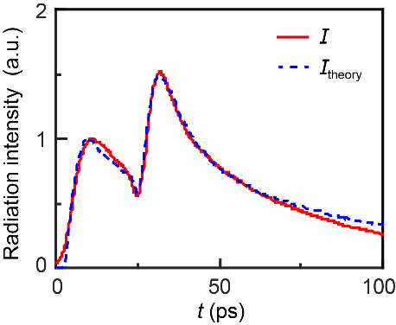

**Fig. S5** A comparison of the experimental data () and the theoretical simulation () under the conditions of ,  and .

By using Monte Carlo simulation to solve the stochastic differential Eqs. S8-S12, the time evolution in **Fig.** **2(a)** can be fitted effectively, as shown in **Fig. S5**. We denote the parameter as follows: ,, , , ,,, , , and. For the optical pumping processes, the injected excitation numbers at the corresponding moments are  and. The broadening of the Gaussian pulse is ~1 ps. By changing the disturbance injection moment and the injected excitation number *N*Ex2, the experimental results shown in **Fig.** **2(f)** and **Fig.** **4(c)** can be fitted.

The normal scattering terms () in the equation of  determine the critical threshold of SE-SF transition. The seed of  creates through the competition between the above terms and the term of *F*, while the term of  contributes a coherent amplification on $σ$ to set up MDM. If the term of is absent, the system could maintain in the SF regime under the density condition of  after the second pumping pulse, as shown in **Fig. S6(b)**. However, after the second pumping pulse is injected, the inserted hot excitons will induce random virtual light fields dispersed in exciton ensemble. These virtual light fields bring phases mismatched with the existing virtual light field shared by MDM. Thus,  is introduced to describe the collapse of cooperative dipole moments  through the disturbance of virtual light fields. In addition, the Auger scattering term  in the equation of exciton number *N* would support the  if the parameter of  is set oversize. But the oversize parameter would also induce a large loss of excitons and a sharp decrease of , which does not match the experimental observation. Meanwhile, the oversize parameter of  is not consistent with the Auger lifetime of carriers reported in a similar system. In our manuscript, the simulation is carried out with the terms of  and *F*. The theoretical results fit the experimental data well.

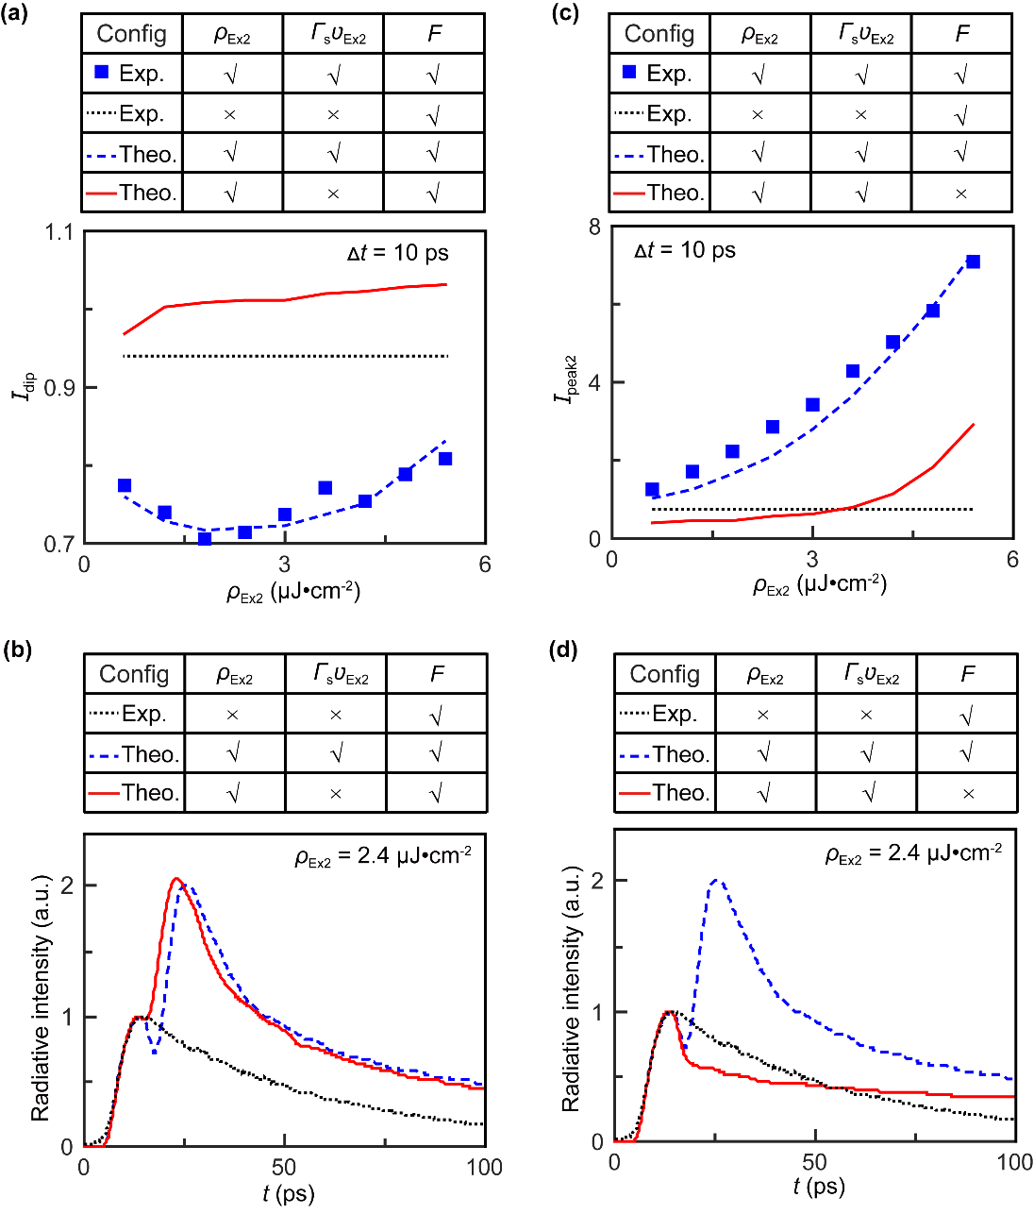

**Fig. S6 Different roles of**  **and *F*.** (a), (b) The major contribution of  on the occurrence of dip behavior. (c), (d) The key role of *F* for the revival effect of .